Third Eye For Blind People Using Ultrasonic Vibrator Glove

Ms. Navya Shree T N
Department of Electronics and Communication Engineering
Nagarjuna College of Engineering and Technology
Bengaluru,India
navyashreenavya9988@gmail.com
Ms.Sumekha P Reddy
Department of Electronics and Communication and Engineering
Nagarjuna College of Engineering and Technology
Bengaluru,India
sumekhapreddy05@gmail.com
Ms.Priyanka M
Department of Electronics and Communication Engineering
Nagarjuna College of Engineering and Technology
Bengaluru,India
priyankapriya6496@gmail.com
H Venkatesh Kumar
Department of Electronics and Communication and Engineering
Nagarjuna College of Engineering and Techonolgy
Bengaluru,India
venkateshkumar.h@gmail.com
Ms. Sumana Shree C S
Department of Electronics and Communication Engineering
Nagarjuna College of Engineering and Technology
Bengaluru,India
shobhasumana71@gmail.com

Abstract— The blind people face many difficulties in the tasks they have to carry out everyday life. It is necessary to give more attention toward finding feasible methods that can be able to help the blind to alert the objects in front of them to avoid collisions. Therefore, to address all of these issues, there is a need to design an effective solution that can help blind people to identify any objects surrounded by blind people without any restrictions. The proposed solution is developing an ultrasonic glove sensor that uses human-powered technology to help the visually impaired persons with the many challenges they face, it is demonstrated that it is easy to use, useful and can be used for many important purposes in daily life for blind people. The wearable device using ultrasonic sensor detects an object and sends a signal to the glove, which will vibrate to alert the user. It is powered by a small battery and controlled by a microcontroller. which processes data received from ultrasonic sensors. The closer you get to the object, the stronger or faster the vibration will be helps the user understand the distance. This makes a practical tool for improving the moral confidence, cost-effective, user-friendly and safety of people who are visually impaired hence they can navigate their surroundings with confidently.

Keywords—Arduino UNO, Ultrasonic sensor, Blind.

Introduction

Blindness greatly affects a person's ability to navigate and connect with his environment. The recent engineering progress has helped the development of devices designed to help individuals with visual loss to achieve their confidence and freedom. Such a device is known as the "third eye" for visually impaired [1]. It uses incentive vibrations to provide sensory information about the surrounding environment. The device is designed as gloves equipped with ultrasonic sensor at the back and vibrators on the fingers. Ultrasonic sensor detects objects in the surrounding area by emitting incentive waves that remove the obstacles. A microcontroller processes this data and converts it into vibration, which is then transmitted to the fingers. This allows the user to see its surroundings through touch, to increase its spatial awareness.
Technological progress continues to improve the quality of life for persons with disabilities. However, social approaches can still introduce challenges, as physical disabled people are often fulfilled with indifference or facial dependence on others for daily tasks. Since the vision is one of the most important senses to understand the world, innovations like "third eye" gloves have played an important role in promoting more freedom and inclusion. Our ability to understand and interact with the external environment depends on our sensory organs, especially vision. For those persons who are blinded visually [2], navigating their surroundings can be extremely challenging, as they cannot rely on the vision to detect obstacles. To address the issue, the project introduces an innovative product called "The Third Eye for the Blind", which is designed to help blindly spoiled individuals to roam safely and independently. Smart blind gloves are an advanced accessory tool that increases mobility and safety for people with vision loss. This includes a series of sensors, including ultrasonic sensors, detecting obstacles in the area around the user. These sensors provide real -time response through vibration or sound alerts, making the user help their environment navigate with more confidence and reduce the risk of conflict. By integrating these sensor technologies [3], the smart blind glove strengthens blind individuals to move more independently and confidently, greatly improves their quality of life [4]. "Third eye for the blind people using ultrasonic vibrator gloves" is the purpose of increasing mobility and spatial awareness for people with vision loss.

According to the World Health Organization, visually impaired persons face many challenges in their daily lives, including difficulties in navigating the spaces and interacting with their surroundings. This innovative project addresses these challenges using sensors and vibration technologies to increase environmental awareness. The main component of this system is an ultrasonic sensor, which emit ultrasonic waves to detect obstacles with the user's path. These waves reflect nearby objects, and microcontroller calculates the distance of each barrier. The gloves are equipped with vibration motors that convert this information into touch reaction. When the users vibrates with different intensity and frequency , when the users approach a barrier, the motors vibrates them for potential hazards and enable them to safely navigate them. This smart glove design helps visually assumes their surroundings more effectively, which helps them to detect obstacles and achieve more freedom in their daily lives [5].
The glove is equipped with receptors with its fingers to provide sensory response to the user. It uses a vibrator controlled by a microcontroller, who receives a signal from an ultrasonic sensor located behind the glove. This sensor emits incentive waves that bounce nearby objects, causing echoes that help to detect obstacles and measure their distance. The microcontroller processes this information and converts it into vibrations felt on the fingers. These vibrations allow the user to feel their surroundings and navigate more secure and confidently.

II OBJECTIVES OF THE PROPOSED SYSTEM

The goal of this project, “The Third Eye for the Blind, is to lay out a portable, wearable [6] device for the visually impaired and those who often must rely on others. To help the visually impaired people to move around from one place to another with confidence by knowing the nearby obstacles using the help of the wearable glove, which produces the ultrasonic waves that notify them with buzz sounds or vibrations [7]. To lay out the device with a portable, cost-efficient, easy-to-manage, and effective system with many more amazing properties and advantages is proposed to support the blind to find the obstacles even in motion by using a motion sensor.

III METHADOLOGY

The layout was marked as a wearable tool that can be worn on any part of the body that feels comfortable with the operator. The bend is fitted with cardinal indible sensors, which can weaken into different parts or cut one depending on the character of the operator. They can either use it on the hand or attach it to the shoulders or knees. Through an inch ultrasonic sensor, the visually myopic is designed to obtain obstacles and objects in various depths of the round, which we discreet leave the silent gate or obstacles at discretion.Which,then informs the operator with beeping and micro vibrations that are natural found by the operator. The quiver increases, and the rate of beeping is correct; Certainly, the space between the obstruction and the operator reduces the characteristics of Ordinal Eye to lie visually in many rooms. Wearing this device, they can avoid the use of completely white sugarcane and other equipment. The principal behind it is to help blind people as a third eye. If the check person passes on the road or in the house, the ultrasonic finder becomes active and checks to get the space between the obstruction and the screen person. If the obstacle is set silently out, it becomes super, and it gives the head to the arduino microcontroller , an extremely speech synthesizer, and chills to chill. The 9V attack is old to power the microcontroller and integral system.

If the obstacle is exclusive to snow, CM places super, and it notifies the open time treatable ahead on the exploitation phone. If the obstruction is inside the cardinal centimeter space, it extremely notifies the “hustler that the obstruction is in the cardinal centimeter forward and quivers. Consider using ultrasonic vibration gloves to help. It depends on the screen soul "seeing" with their tertiary eye the hypothesis of pensive place, which is force around animals (bats, dolphins, etc.) leaving point you. and utter words and examine them to high-frequency subjects. the ring that bounces game inch this suit glove. An ultrasonic sensor is a sensor that emits high sound waves. (Beyond many limits) listen to get the ringing of these waves reported to them close objects spring game it leave work glove. It then converts these resonances into vibrations that can. The wearer gets to look at it. The wearer puts on gloves and moves [8].
Property men in association with nursing, such as arsenic, inaudible aim, espial set, and space, are allowed. extremely that the wearer can “feel” their surroundings and be able to navigate more efficiently. The hypothesis is that this engineering is like the engineering of old, inching around present technologies. Assistive equipment for the blind, such as fleets or sonar eyes based on echo position, however, ultrasonic vibrator gloves have advantages. Be more careful and provide more details. reaction done vibes, which are been spoken to the operator's preferences and necessarily. It should be noted that this tech still exists. evolutionary stairs and foster search and examination of the strength and notable. The third eye for blind people is a glove with ultrasonic vibrations at the fingertips. The vibrator is limited to a low-amp microcontroller, which receives input from an ultrasonic sensor placed on the back of the glove. the mind of exploitation associate in nursing inaudible vibrator mitt (glove) to service screen dwell "see" done their tertiary heart is founded along the rule of echo sounding, which is the power of around animals (such as insane and dolphins) to pilot and get objects away, emitting sounds and analysing the echoes that spring game. In this suit, the glove would bear inaudible sensors that breathe high-frequency go waves (above the run of human hearing) and find the echoes of these waves as they bounce game from close objects [9]

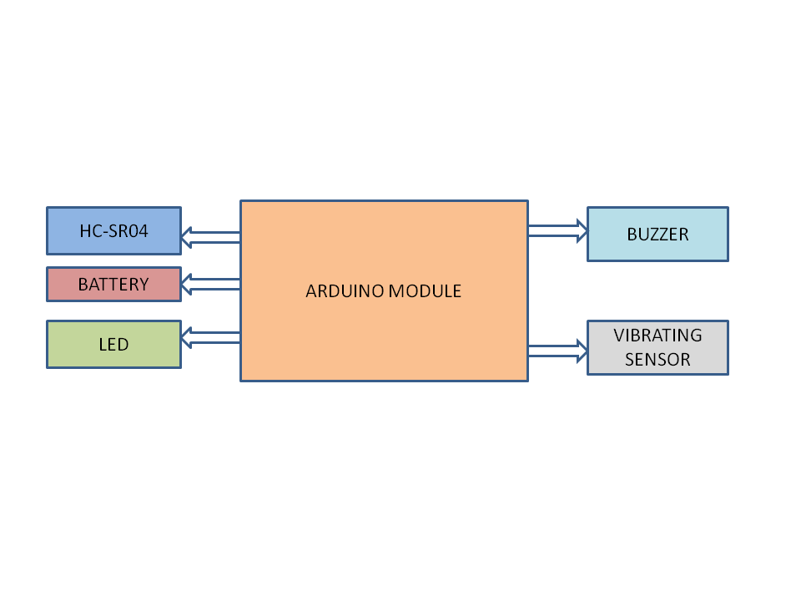

Fig.1.Block diagram of the third eye for blind people using ultrasonic vibrator glove

In general, The" Third Eye for the Blindness," using ultrasonic vibration gloves, has a block illustration with the following main factors. inaudible sensor to spot good obstacles microcontroller to recycle space information and quiver drive is organic into the mitt(glove) to give "tertiary eye" tactile feedback to service them and search their landscape. Explaining the block illustration Ultrasonic [10] Find or It emits ultrasonic swells that bounce off objects and return to the finder. It measures, however, how long it takes for the swells to go and lead associate in nursing aim. By calculating distance It sends distance information as an electrical signal to the microcontroller. microcontroller (e.g., Arduino) admits distance information from the ultrasonic Find or. It methods the information to set the relevant quiver strength grounded along amp apt space [11]. It sends control signals to the vibration motor to acclimate the vibration position. The quiver motor (controlled by inch gloves) takes electric signals from the microcontroller. It creates a climate of different intensities depending on the signal entered and provides haptic feedback to the stronger regarding the propinquity of the handicap.

IV PROPOSED SYSTEM

In this section, our proposed system is described by a block diagram, a circuit diagram, a flow chart, and software used.

A. Block Diagram

This proposed system consists of the equipment, like the Arduino ultrasonic sensor vibrating motor, for finding the obstacles and letting the operator know about the obstacle. Switches Jumper cable power bank Male and female header pins 3.3-volt battery stickers to make the device wearable as a band for wearing for the operators. The wiring of the twist is through an inch amp chase away. The ground of the vibration motor is connected to GND of the Arduino. The +ve of the quiver drive is bound to the tertiary stage of the change. The ultrasonic sensors are wired accordingly. The inaudible Find or glove VCC is on to the Arduino glove inaudible. Find or glove GND is on to the Arduino glove GND inaudible. Find or stick trim is added to the Arduino glove; Cardinal inaudible Find or stick ring is on to the Arduino stick cardinal. The switch used here is for selecting the vibration mode to solder the female headers for the Arduino to the board. extremely exploit the gum tie, the moving drive, and solder the wires to it. Then the connection of the LED is done. extremely tie the change. Connect the header pin for ultrasonic sensor and to battery input. Complete the extremely mixed elements and tie the Arduino and the inaccessible explorers in the table. To create a module for the hand, connect the ultrasonic sensor to the board using 4 jumper cables. Near the inch, and later complete the connection through the Arduino table, upload the cycle to the Arduino table and force it.

B.CIRCUIT DIAGRAM

The "third eye for blind" using an ultrasonic vibration glove usually adds an ultrasonic sensor (Eg, HC-SR04) to find distant information and meaning to find obstacles for a microcontroller (eg Arduino); The major factor is the reference to force. Ultrasonic sensor includes the resistance and transistors required to control the motor based on sensor reading in microcontroller and vibrating motor.Circuit breaker: Ultrasonic Sensor waves, It measures the distance it takes for the echoic beat to take. By calculating the distance from the object, it sends an output voltage signal proportional to distance. Microcontroller (Arduino): take the parallel EMF point from the inaudible Find or. Convert analogue signals to digital distance values. It determines the fit quiver strength founded along space. Send control signals to the vibrating motor. Vibratorv: A small motor that causes vibration when driven. The strength of the pulses gets work limited away, adjusting the EMF practically to the pulse circuit operation. the sensor: the inaudible Find or emit pulses of go waves Activate the waves. the sensor: the inaudible find or emits pulses of go waves echo. along the sentence it takes for the go to spring back vibration control: founded along the deliberate space, the microcontroller adjusts the force supplied to the quiver drive. This results in vibrations of different intensities.

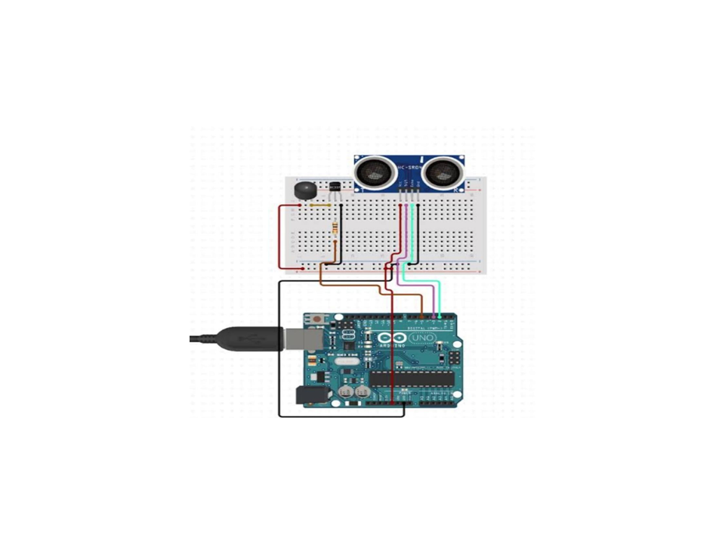

Fig 2 Circuit Diagram of the proposed system

C. Flow chart

Fig 3 will describe the overall process of how the glove will work, begin: Begin the Method of awareness and Answer. Activating the ultrasonic sensor: Ultrasonic sensors in the glove or headband send sound waves to Find obstacles. Introduction to obstacles: The sensor measures the time it takes for sound waves to bounce back. (echo) if block is felt inside amp planned run go to the close measure. If no obstruction is Find Continue to Find. Long distance calculation: using flight time Information from ultrasonic sensors.

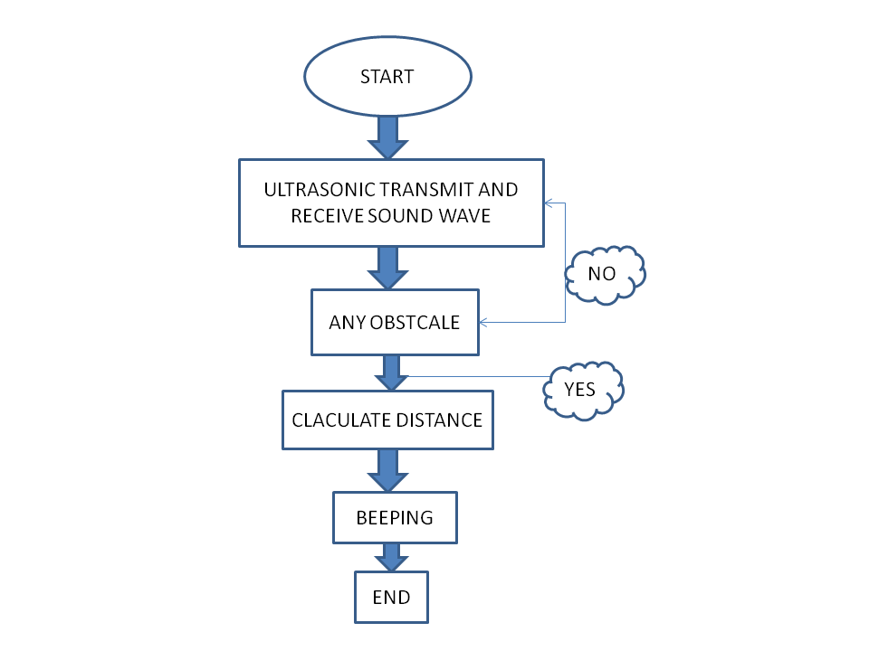

Fig 3 Flow Chart of the proposed system

The system calculates the distance to the obstacle. Feedback mechanism: The gloves adjust the intensity or Layout of vibration. this depends along the space from the obstruction. Closer obstacles = stronger or faster vibrations. foster obstacles = weaker or slower vibrations Operator comments: the exploiter Explains the vibes as a result to run or void obstacles repetitive feelings: the unit incessantly iterates to find and answer to the surround inch material sentence.

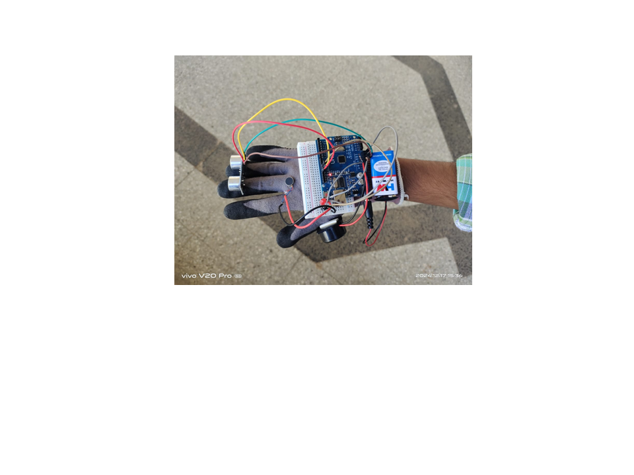

Fig 4 The prototype of the third eye for blind people using
ultrasonic vibrator sensor
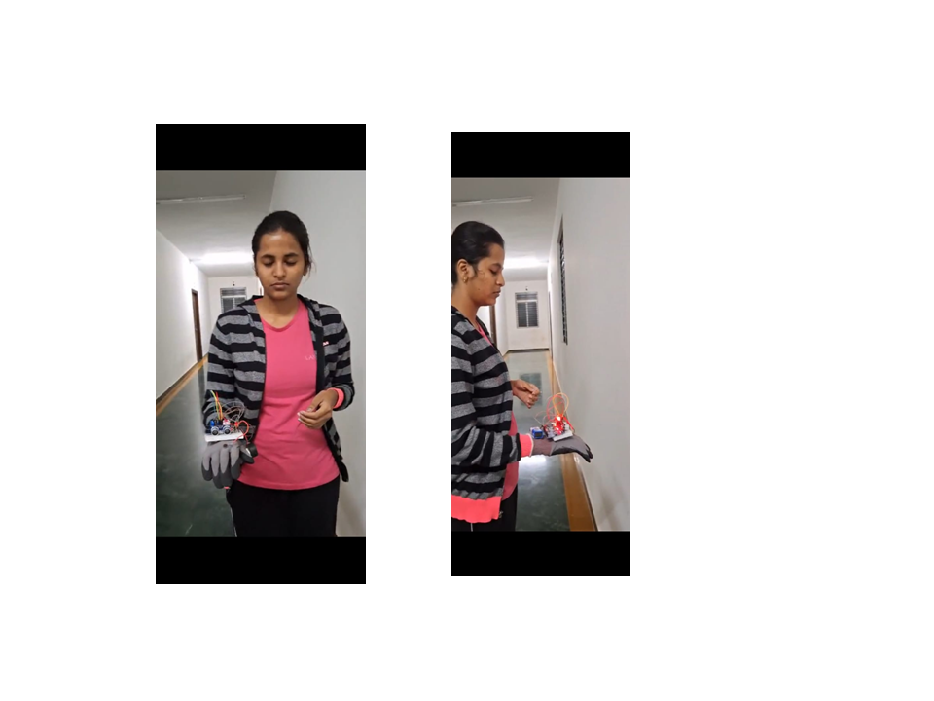

Fig 5. Person wearing the prototype device

V. CONCLUSION

In this work the Ultrasonic vibrating glove wearing the blind person help to walk and estimate the distance from objects in front them and surrounding for a certain distance. Hence the Ultrasonic vibrating glove using sensors, powered by a small battery and controlled by a microcontroller will judge the distance by giving the stronger or faster the vibration will be helps the user understand the distance in the project. It is an affordable technology, portable and has its own limitations which can be overcome by using advanced integrated technology to reduce the power consumption and to make miniature in nature.

ACKNOWLEDGEMENT

We express our gratitude to Mr. Praveen Maurya, Technical Assistant of the Creative Lab of Nagarjuna College of Engineering and Technology, Bengaluru for their valuable insights and knowledge that significantly contributed to the study.

REFERENCES

[1] K.Manjari, M. Verma, and G. Singal, “A survey on Assistive Technology for visually impaired,” Internet of Things, vol. 11, p. 100188, Sep. 2020.

[2] R.Tapu, B. Mocanu, and T. Zaharia, “Wearable assistive devices for visually impaired: A state of the art survey,” Pattern Recognit Lett, vol. 137, pp. 37–52, Sep. 2020.

[3] E. Brady, M. R. Morris, Y. Zhong, S. White, and J. P. Bigham, “Visual challenges in the everyday lives of blind people,” in Proceedings of the SIGCHI Conference on Human Factors in Computing Systems, New York, NY, USA: ACM, Apr. 2013, pp. 2117–2126.

[4] S. Shoval, I. Ulrich, and J. Borenstein, “Robotics-based obstacle-avoidance systems for the blind and visually impaired - Navbelt and the guidecane,” IEEE Robot Autom Mag, vol. 10, no. 1, pp. 9–20, Mar. 2003.

[5] P. Sharma and Mrs. S. S. L, “Design of Microcontroller based Virtual Eye for the Blind,” IJIREEICE, pp. 26–33, Mar. 2015.

[6] D. Dakopoulos and N. G. Bourbakis, “Wearable Obstacle Avoidance Electronic Travel Aids for Blind: A Survey,” IEEE Transactions on Systems, Man, and Cybernetics, Part C (Applications and Reviews), vol. 40, no. 1, pp.25–35, Jan. 2010.

[7] A. Batool and S. Naz, “Third Eye For Blind,” Asian Journal Of Convergence In Technology, vol. 7, no. 2, pp. 1–4, Aug. 2021.

[8] V. Filipe, F. Fernandes, H. Fernandes, A. Sousa, H. Paredes, and J. Barroso, “Blind Navigation Support System based on Microsoft Kinect,” Procedia Computer Sci, vol. 14, pp. 94–101, 2012.

[9] P. Bhardwaj and J. Singh, “Design and Development of Secure Navigation System for Visually Impaired People,” International Journal of Computer Science and Information Technology,vol.5,no.4,pp.159164,Aug.2013.

[10] A. Kumar, R. Patra, M. Manjunatha, J. Mukhopadhyay, and A. K. Majumdar, “An electronic travel aid for navigation of visually impaired persons,” in 2011 Third International Conference on Communication Systems and Networks (COMSNETS 2011), IEEE, Jan. 2011, pp. 1–5.

[11] G. Saranya, S. V Tharun, T. Tamilvizhi, and R. Surendran, “Intelligent Wearable Device for Visually Impaired Person to act as a Third Eye,” in 2023 4th International Conference on Electronics and Sustainable Communication Systems (ICESC), IEEE, Jul. 2023, pp. 889–895.

[12] S. Das, S. Patro, R. Das, and A. Mishra, “Arduino based Safety Device for the Visually Challenged,” in 2019 International Conference on Communication and Signal Processing (ICCSP), IEEE, Apr. 2019, pp. 0601–0605.

[13] D. Chaube, “Implementation of Third Eye for Blind People Using Ultrasonic Vibrator Glove,” Int J Res Appl Sci Eng Technol, vol. 12, no. 4, pp. 2423–2427, Apr. 2024.

